Whitehaven and District Beekeepers Newsletter Spring 2014

Apiary News
After over-wintering in Haile, six hives and one nuc box of bees were returned to the Apiary in early February. It was very encouraging to find active bees in all the hives, and this was confirmed at the first inspection in March (see below for a full report by Val Sullivan and photos from John Forster)
First inspection on Sunday 23rd March
Fifteen people turned up for the first Apiary Inspection of the 2014 season, including several new beekeepers, all fresh from the Beginners Course two weeks ago.
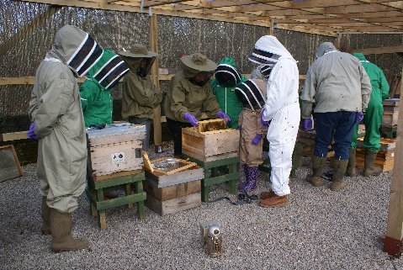
Although it was cold at the “Overspill” car park at West Lakes Science Park it was sunny, and by the time we had wandered to the Apiary the temperature had risen to a pleasant, almost shirt sleeves sort of afternoon. At the shed those Beekeepers without suits were kitted out and others put on their own brand new suits. We reminded everyone about the disposable gloves policy and the Apiary rules which minimise the risk of introducing pests and diseases. We then went through the object of the first inspection of the season, including checking food supplies, examining for brood and for signs of disease.
All seven hives were opened and inspected. All have brood in all stages of development. The Queen bees complied with the occasion in five of the hives, strolling over frames so that everyone could see them and compare them with the worker bees for size and shape.
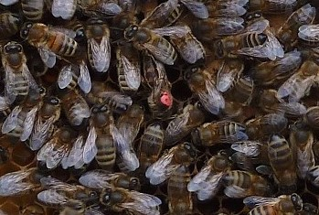
One Queen had nearly lost her red marking but was so magnificent that she was still obvious among her subjects. At this time of the season there were no drone bees to see.
Most of the 2.5kg fondant bags sitting on the crown boards were almost empty but every hive had plenty of stored food in the frames. The fondant was left on for the bees to finish the last little bits.
Only one Varroa mite was found on a floor insert, all others containing just debris, wax scales and a few minute wax mites. All the brood looked healthy and although one hive contains only a small colony we were optimistic about the chances of a successful season.
The apiary garden
The planned Gardening Day on March 16th was postponed as the ground remained very wet after the persistent rain this winter and spring, so instead of gardening, we made frames at Brackenwray (see below).
A small group met on Tuesday April 1st to make a start on planting out the heathers, and do some weeding, and another Gardening Day is planned for the Tuesday after Easter (see dates for your Diary for details)
Nuclei of bees for sale
Whitehaven Beekeepers hope to produce nucs of bees for sale to members this season. The price for a nuc of bees (including a nuc box) will be £150.00. These will be sold on a first-come, first-served basis as they become available.
If you are interested, please let me know as soon as possible and I will add your name to the waiting list.
Frame making afternoon at Brackenwray on Sunday16th March
On Sunday 16th March 14 beekeepers turned up at the Brackenwray “Machinery Shed” to put together the frames needed at the Association Apiary for the 2014 season. After a short explanation of frame types and choices, and then a rundown on the correct way to construct them by Alan Robson, we had 100 deep frames all correctly nailed and fitted with foundation within a couple of hours. After that we retired to the house for tea and cake, and inevitable “bee-talk”.
Summary of different frames available
For those new beekeepers who were unable to get to the frame-making session, here is a summary of the different types of frame available and meaning of the letters and numbers used in the catalogues;
BS Frames = British Standard Frames: These will fit National hives or WBCs, so are used by most beekeepers. There are two sizes:
DN = Deep National: These are the frames to fit the brood box.
SN = Shallow National: These are the correct frames for the honey supers.
And then the numbers: From 1 to 5; (excluding 3)
DN1 frames: have a top bar which is 7/8” inch wide , and straight side bars which are 7/8” wide and 8 ½” deep. N.B. These will need narrow plastic ends as spacers to keep the frames at the correct distance apart in the brood box.
DN2 frames: have the same straight side bars, but the top bar is wider (i.e. 1 and 1/16th inches) These are stronger than DN1 frames and discourage formation of brace comb.
DN4 frames: have a top bar which is 7/8” inch wide with “Hoffman” side bars. These are 1 and 3/8th inch wide at the top and taper to 7/8th at the bottom so are self- spacing once in the brood box, so spacers are not needed.
DN5 frames are the same as DN4s except the top bar is wider (1 and 1/16”) for extra strength.
SN1, SN2, SN4, and SN5 are as above except the side bars are shorter (only 5 ½ inches long). Remember that if you go for SN4 and SN5 you will not be able to adjust the number of honey producing frames in the super boxes as the season progresses
Other frame sizes include Manley, Smith, Commercials, Dadant and Langstroths. Make sure you order both the correct sized frames for your choice of hives, and foundation to match. Mistakes can be expensive!
(Thanks to Val for this summary)
Events
Beginner’s Day on Saturday March 8th
After some early concerns about numbers attending, we were able to run a successful Beginner’s Day at Lamplugh Village Hall, with 14 attendees. Paul, Val and Dominic all presented an introduction to different aspects of beekeeping, and Alan Robson gave an excellent demonstration of the range of hives and equipment that is needed.
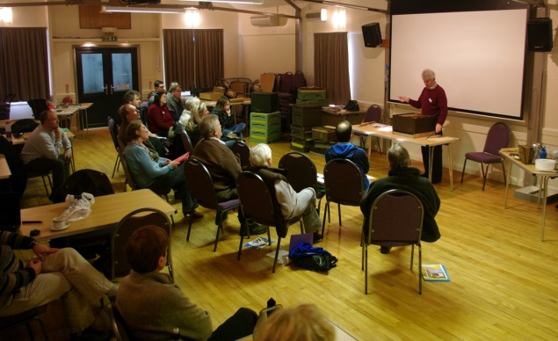

Dates for your Diary
Programme for apiary visits, April –June
Teaching meetings will be held at the branch apiary at Westlakes Science Park on the following dates;

Monday 21st April (Easter Monday)
Saturday 3rd May
Sunday 18th May
Saturday 31st May
Sunday 15th June
Saturday 28th June

All meetings will start promptly at 13.00, please park in the overspill carpark at Westlakes

Next Gardening Day

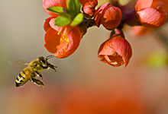
The next Gardening Day at the apiary site is taking place on Tuesday 22nd April, starting at 13.00. The main objective is to plant lots of herbs, and the remainder of the heather plants. It will also be an opportunity to see how the garden has changed since last September.
Please bring your own gardening tools. Everyone is welcome, especially any of the younger bee-keepers. Although this is a weekday, it does fall within the Easter school holidays.

Northern Bee Auction

The fourth Northern Bee Auction is being held at Houghton Village Hall on Saturday 26th April. For full details see their website, www.northernbeeauctions.co.uk . Committee members from WDBKA will be present to give advice and support if required. If anyone has any equipment that they wish to sell, please contact Peter Harris on 078304 32014.
For Sale:
A four frame honey spinner (not seen, so condition unknown) is available for sale from Mr Todd, at 20 Sandy Grove, Egremont. Price negotiable. Please contact Mr Todd on 01946 821411 if you are interested.
Finally, a brief reminder about the “Good Husbandry” Day being run by Penrith Beekeepers on Saturday July 12th . Details have been circulated, or are available on their website www.penrithbeekeepers.org

